**Invoice module:**

Current invoice creation fields

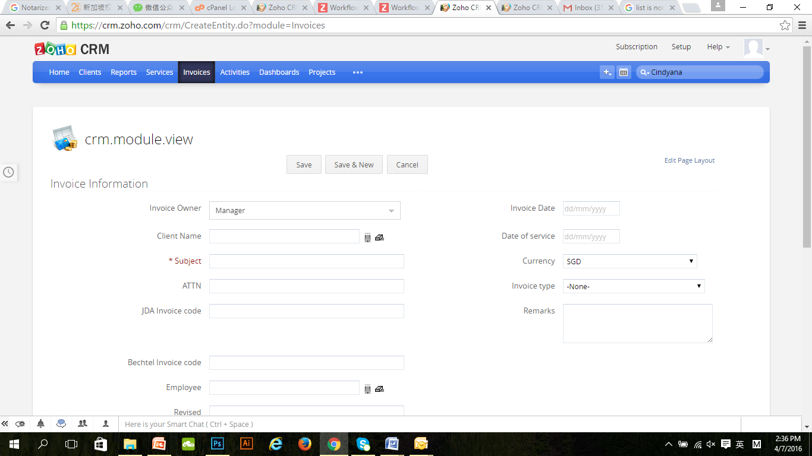

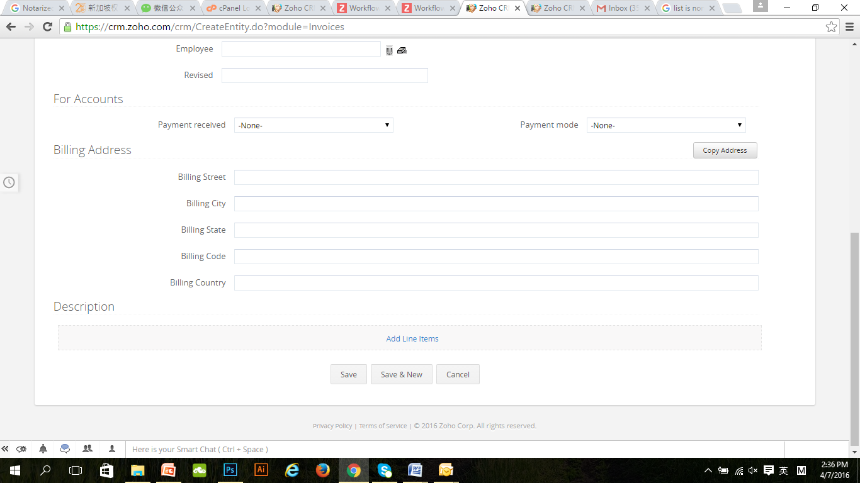

Invoice template- as attached.

*\*highlighted parts pulls information from fields as seen above\**